**Hunter Biden’s Tangled Tale Comes Front and Center**

**By Adam Entous,**[**Michael S. Schmidt**](https://www.nytimes.com/by/michael-s-schmidt)**and**[**Katie Benner**](https://www.nytimes.com/by/katie-benner)

* Jan. 11, 2023
* The New York Times

The way Republicans tell it, President Biden has been complicit in a long-running scheme to profit from his position in public life through shady dealings around the world engineered by his son, Hunter Biden.

Taking a first step in their long-promised investigation, Republicans on the House Oversight Committee on Wednesday [demanded information about the Bidens’ banking transactions](https://www.nytimes.com/2023/01/11/us/politics/biden-finances-congress.html) from the Treasury Department. And in an earlier [report on the Bidens](https://oversight.house.gov/wp-content/uploads/2022/11/Interim-Staff-Report-A-President-Compromised-The-Biden-Family-Investigation.pdf) intended to lay the groundwork for hearings they plan to hold, they said they had evidence “demonstrating deliberate, repeated deception of the American people, abuse of the executive branch for personal gain, use of government power to obstruct the investigation” and more.

The real Hunter Biden story is complex and very different in important ways from the narrative promoted by Republicans — but troubling in its own way.

After his father became vice president, Hunter Biden, a 52-year-old Yale-educated lawyer, forged business relationships with foreign interests that brought him millions of dollars, raised questions about whether he was cashing in on his family name, set off alarms among government officials about potential conflicts of interest, and provided Republicans an opening for years of attacks on his father.

And after the death of his brother, Beau, in 2015, Hunter descended into a spiral of addiction and tawdry and self-destructive behavior.

He is sober now and no longer entangled in foreign business deals. He is a visible presence in his father’s life — his oldest daughter was [married at the White House](https://nytimes.com/2022/11/19/us/politics/naomi-biden-wedding.html) in November, and he attended a state dinner last month.

But his travails remain front and center in Washington **in ways both legal and political.**

David C. Weiss, the U.S. attorney for Delaware, is closing in on a decision about whether to prosecute Hunter Biden on charges stemming from his behavior during his most troubled years.

Investigators have pored over documents related to and questioned witnesses about his overseas business dealings. They include his role on the board of Burisma, a Ukrainian energy company led by an oligarch who at the time was under investigation for corruption — a position that Hunter accepted while his father, as vice president, was overseeing Obama administration policy in Ukraine.

They also include his equity stake in a Chinese business venture, and his failed [joint venture](https://www.washingtonpost.com/politics/2022/03/30/hunter-biden-china-laptop/) with a Chinese tycoon who had [courted well-connected Americans](https://www.nytimes.com/2018/12/12/business/cefc-biden-china-washington-ye-jianming.html) in both parties — at one point he gave Hunter Biden a large diamond as a gift — but was later detained by Chinese authorities.

Investigators have similarly sought information about interactions between Hunter Biden’s business associates and his father.

But Mr. Weiss, people familiar with the investigation say, appears to be focused on a less politically explosive set of possible charges stemming from his [failure to meet filing deadlines](https://www.nytimes.com/2022/03/16/us/politics/hunter-biden-tax-bill-investigation.html) for his 2016 and 2017 tax returns, and questions about whether he falsely claimed at least $30,000 in deductions for business expenses.

Mr. Weiss is also said to be considering charging Hunter Biden, who has openly acknowledged his years of struggle with drugs and alcohol, with lying on a U.S. government form that he filled out to purchase a handgun in 2018. On the form, he answered that he was not using drugs — an assertion that prosecutors might be able to challenge based on his erratic behavior and possible witness accounts of his drug use around that period.

A veteran federal prosecutor, Mr. Weiss was nominated in 2017 as U.S. attorney by President Donald J. Trump. He was kept on by Attorney General Merrick B. Garland after President Biden took office to avoid any suggestion of political meddling in the investigation. Mr. Weiss has been given the authority by the Justice Department over whether to bring charges and could make a decision at any time.

Hunter Biden’s lawyers have argued to prosecutors that the potential charges are considered so narrow by the department that even if prosecutors believe they can prove them, they are almost always dealt with through civil actions without bringing criminal charges.

Regardless of what the department decides, Republicans who now control the House intend to intensify their scrutiny of Hunter Biden in a bid to inflict damage on his father as he prepares for his likely 2024 re-election bid.

Hunter Biden’s career had long crossed paths with Democratic politics and constituencies associated with his father, stoking **questions about favoritism.**

Despite their years of efforts — including Mr. Trump’s attempt to [muscle Ukraine](https://www.nytimes.com/2019/12/29/us/politics/trump-ukraine-military-aid.html) into helping him [sully the Bidens](https://www.nytimes.com/2019/05/01/us/politics/biden-son-ukraine.html), an escapade that led to his first impeachment — Republicans have yet to demonstrate that the senior Mr. Biden was involved in his son’s business deals or took any action to benefit him or his foreign partners.

And some of what Republicans have cast as evidence that could implicate President Biden in questionable behavior by his son — assertions that father and son shared bank accounts, for example, or that the elder Mr. Biden was a partner with his son in his stillborn deal with the Chinese tycoon — is contradicted or undercut by a fuller look at Hunter Biden’s activities.

An examination by The New York Times of Mr. Weiss’s investigation and Hunter Biden’s journey to this juncture does not provide either side with the narrative they would prefer.

It highlights how he aligned himself with foreign actors eager to leverage their connections to him to further their own interests. But it also underscores how far removed the most likely legal charges against him are from the issues most aggressively promoted by Republicans — and how his father’s opponents have often twisted or exaggerated the story of his descent to score political points.

This account is based on interviews with his former business partners, family members and close friends, as well as officials and lawyers familiar with the Justice Department investigation.

It also builds on previous reporting by The Times and other news organizations, and draws from a selection of Hunter Biden’s leaked emails that The Times has verified as authentic, out of thousands attributed to him that were disseminated by allies of Mr. Trump ahead of the 2020 election to try to undercut the Biden campaign.

What emerges is the story of a man battling with personal demons against the background of family tragedy and under the glare of public scrutiny. It is an instructive look at the enduring Washington practice of trading on access and influence.

It is a case study of the challenges of dispensing justice to a supremely politically connected target. And it is a tale of how personal struggles can be weaponized in today’s hyperpartisan, take-no-prisoners political environment.

As Stephen K. Bannon, Mr. Trump’s former strategist, put it: “I don’t care about Hunter’s feelings. This is war.”

Image

**Taxes, a Gun, Addiction and Loss**

Just before 5 p.m. on Friday, Oct. 12, 2018, Hunter Biden received an urgent-sounding email from his accountant, Bill Morgan.

Mr. Morgan had been hounding Hunter, who had recently completed a stint in rehab for addictions to crack cocaine and alcohol, to provide him with information needed to complete his 2017 personal and business tax returns.

What he owed was substantial, more than $800,000.

“I did not hear back from you,” Mr. Morgan wrote, adding that he needed his client’s address so he could FedEx him the returns, which had to be filed within three days to meet the deadline.

That same Friday afternoon, however, Hunter Biden, whose father’s second term as vice president had ended nearly two years earlier, seemed to have other matters on his mind. He had misplaced his iPhone and had gone to an AT&T store in Wilmington, Del., to buy a new one. He then went into a shop across the street — StarQuest Shooters & Survival Supply — and bought a .38-caliber handgun.

His exposure to the tax and gun charges traces back to that October afternoon, and to his intensifying problems with addiction and his loss of relationships with three of the people closest to him: a longtime colleague, his wife and his brother.

For nearly 15 years, he had a safety net of sorts in Eric Schwerin, his business manager, whose expansive role included helping him manage his finances and keeping him out of the exact kind of trouble he was facing by late 2018.

Hunter had three daughters and an expensive lifestyle in Washington. He made more than $800,000 in 2013 and more than $1.2 million in 2014, the year he joined the board of Burisma, but in some years he struggled to cover expenses.

When he fell short between paychecks and his checking accounts became overdrawn, he would rely on Mr. Schwerin to shift money from savings accounts to get his debit cards working again.

But Mr. Schwerin’s role was tested by what was then a Biden family secret: Hunter’s alcoholism, which dated to the early 2000s.

While Mr. Schwerin helped cover for Hunter at work during absences when he was in rehab, Beau, Hunter’s older brother, made sure he attended Alcoholics Anonymous meetings and steered him back toward sobriety whenever he relapsed.

After Beau died of brain cancer in 2015, Hunter had another relapse and, for the first time, his brother was not there to help him. Hunter brought his drinking briefly back under control, but the first anniversary of Beau’s death sent him into a spiral of depression that led to an addiction to crack cocaine.

He and his wife at the time, Kathleen Buhle, had separated after his 2015 relapse, and their relationship deteriorated as his problems with addiction intensified, culminating in their acrimonious divorce in 2017.

Hunter spent much of the summer of 2018 in Wilmington, using drugs and alcohol in increasingly public ways that, friends say, risked attracting attention just as his father was weighing a 2020 presidential run. At the urging of family members, Hunter flew to Los Angeles in August and checked into a rehab facility, after which he lived around the clock for a time with a “sober companion.”

One question federal prosecutors have examined is whether, less than two months after completing rehab, Hunter was using drugs again when, on Oct. 12, 2018, he ignored Mr. Morgan’s email about his taxes and answered “no” on the federal form asking whether he was using drugs when he bought the .38 handgun.

Hunter later told friends that he believed he was sober that day, though his behavior remained erratic. He recounted going into the gun store on a whim and buying the .38 because he thought spending time at a shooting range would help him avoid a relapse. (Beau frequented a range when he was in the Delaware Army National Guard, and the two brothers would sometimes shoot skeet together.)

Not long after the purchase of the gun, Beau’s widow, Hallie Biden, with whom Hunter had a romantic relationship after his separation from Ms. Buhle, found the weapon in his truck. Hunter had ominously told a close family friend, “I know you all think the wrong brother died.”

Fearing he might use the gun to take his own life, Ms. Biden tossed it in a dumpster.

That November, Mr. Morgan tried once again to get Hunter’s attention. Not only did he still need to file his 2016 and 2017 tax returns, but now the I.R.S. had instructed the State Department not to renew his passport because of his outstanding tax liens.

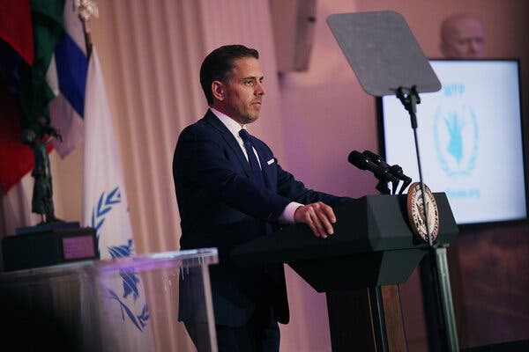

Hunter Biden has openly acknowledged his years of struggle with drugs and alcohol.Credit...Teresa Kroeger/Getty Images

**Opportunity and Peril Abroad**

Hunter Biden’s career had long crossed paths with Democratic politics and constituencies associated with his father, stoking questions about favoritism. For much of the 2000s, he had a thriving domestic lobbying practice, which he set up with the help of one of his father’s longtime advisers.

But Hunter gave the lobbying business up after his father was selected as Barack Obama’s running mate in 2008. Hunter had to scramble to find new sources of income, and by his father’s second term as vice president, he was being approached about — and seeking out — opportunities abroad.

A driving force behind Hunter’s international work was a new business partner, Devon Archer, an ambitious, gregarious former Abercrombie & Fitch model who went to Yale, started his career with Citicorp in Asia and dreamed of one day becoming an ambassador.

It was with Mr. Archer that Hunter would first jump into business in Ukraine and China, the activities that more than any others would ensnare him in years of scrutiny.

One of the first ventures Mr. Archer brought Hunter into turned out to be something of a bust — a deal with Shanghai-based BHR Partners that never fulfilled its ambition of making big investments in the United States.

[Hunter served on the venture’s board starting in 2013](https://www.nytimes.com/2021/11/20/world/hunter-biden-china-cobalt.html) and acquired a 10 percent stake in it after his father’s term as vice president ended in early 2017. Mr. Trump’s allies made the stake an issue in the 2020 campaign, and Hunter sold it after his father became president for what he told associates was a small loss.

But Mr. Archer found an opportunity in Eastern Europe that was lucrative from the start. During a visit to Moscow in early 2014, Mr. Archer was introduced to the oligarch who owned Burisma, the Ukrainian energy company. Excited about the opportunity, Mr. Archer told Hunter that the oligarch, Mykola Zlochevsky, “appears incredibly legit and great guy.”

In fact, Mr. Zlochevsky was under scrutiny from British authorities who were investigating whether he had illicitly taken millions of dollars worth of Ukrainian assets. And he had become concerned about his standing in Washington after he was prevented from boarding a flight to the United States. He later learned that his U.S. visa had been revoked by officials at the American Embassy in Kyiv.

Burisma hired the investigative firm Kroll to conduct a background check on Mr. Archer. According to internal Burisma emails, Kroll reported that Mr. Archer “appears to be well-connected in the elite circles of the Democratic Party,” through his relationship with John Kerry, then President Obama’s secretary of state. The Kroll report also noted that “Robert Hunter Biden, the second son of incumbent U.S. Vice President Joe Biden, is Archer’s business partner.”

Mr. Archer thought he could be helpful to Hunter by encouraging Burisma to retain Boies Schiller Flexner, a law firm that Hunter worked for.

When Mr. Zlochevsky learned that Hunter was attending a conference in Lake Como in Italy, he traveled to the hotel where he was staying to meet with him. During a private lakefront stroll, the oligarch offered him a seat on the board alongside Mr. Archer.

At the time, Hunter was sober, and when he accepted the board seat, he appeared to be fully cognizant of the thorny issues he would face by tying himself to Burisma while his father was overseeing U.S. policy in Ukraine.

“This could be the break we have been waiting for,” he told Mr. Archer in an email.

But he added, “They need to know in no uncertain terms that we will not and cannot intervene directly with domestic policymakers, and that we need to abide by FARA and any other U.S. laws in the strictest sense across the board,” referring to the Foreign Agents Registration Act.

That law requires those who try to influence government officials or government policies on behalf of foreign entities to register with the Justice Department and to report on their activities.

Hunter Biden wanted to see the role as consistent with U.S. policy, telling one friend in an email that “helping out a domestic Ukrainian gas producer as a bulwark against Russian aggression seemed like I was on the side of the angels.” When Burisma’s announcement that he had joined its board brought criticism, he told the friend that he was caught off guard.

American officials who worked on Ukraine issues were upset to learn of Hunter’s role at Burisma. They were concerned it could undermine U.S. efforts, led by Vice President Biden, to persuade Ukrainian leaders to combat rampant corruption, including by investigating oligarchs, a group that included Mr. Zlochevsky.

Image

Vice President Biden met with President Petro Poroshenko of Ukraine in 2015. Hunter Biden served on Burisma’s board during a period when his father oversaw the Obama administration’s Ukraine policy.Credit...Michael Appleton for The New York Times

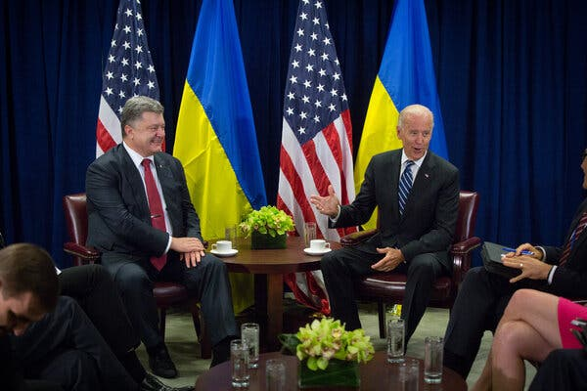

The younger Mr. Biden’s main point of contact at Burisma, Vadym

Pozharskyi, would press him to help fix Mr. Zlochevsky’s visa issues in the United States. To insulate Hunter Biden from the requests, a lawyer in private practice who had previously served as a top immigration official in the Obama administration was brought in to handle the matter.

In at least one known instance, however, Hunter agreed to play a more hands-on role. In February 2015, Mr. Zlochevsky was preparing to fly to Mexico, and Mr. Pozharskyi was worried that the oligarch would not be able to get a Mexican visa because of his problems in the United States.

Hunter emailed a prominent Mexican businessman, the grandson of one of the country’s former presidents, and asked him to help make sure Mr. Zlochevsky “doesn’t have any problems when he comes.” The request failed nonetheless.

Hunter Biden’s ties to Mr. Zlochevsky became increasingly untenable later that year when the American ambassador to Ukraine, Geoffrey R. Pyatt, delivered [a speech](https://www.justsecurity.org/wp-content/uploads/2019/09/Remarks-by-US-Ambassador-Geoffrey-Pyatt-at-the-Odesa-Financial-Forum-on-September-24-2015-ukraine.pdf) in which he accused the prosecutor general’s office in Ukraine of misconduct for not cooperating with Britain’s investigation of Mr. Zlochevsky.

Mr. Pozharskyi wanted to know why the owner of Burisma had been singled out in such a public way. Again, the task of contacting U.S. officials about Mr. Zlochevsky was outsourced to others to keep responsibility for it away from Hunter. Mr. Schwerin, the business manager, suggested that Burisma retain a separate consulting firm, which could meet with the ambassador and other American officials.

Despite criticism of the oligarch within his father’s administration, Hunter did not want to give up his role at Burisma, which was not particularly demanding of his time and continued to pay him handsomely — about $600,000 a year — even after he started smoking crack and stopped responding to emails from Mr. Pozharskyi.

But the Burisma paycheck was not enough to fund his family’s lifestyle. According to Mr. Schwerin’s rough calculations, Hunter would need to make more than $1 million annually just to cover fixed expenses, including mortgages, alimony payments to Ms. Buhle and tuition for their three girls.

“Anything beyond that would be money for your use,” Mr. Schwerin wrote to him. “This does NOT include money for back taxes.”

After Mr. Archer was indicted in 2016 for his alleged role in a bond scheme, Hunter was left to find new deals himself. He told associates that he thought his best option for a game-changing payday was a blockbuster deal with a Chinese energy tycoon named Ye Jianming and his company, CEFC.

Hunter Biden was first approached in 2015 about working with Mr. Ye by a businessman he knew vaguely — their daughters were classmates. The businessman had sent Hunter an email saying Mr. Ye might be interested in donating money to a charity, World Food Program USA, on whose board Mr. Biden served, and in discussing “investment opportunities.”

Hunter’s discussions with CEFC did not get serious until after he met Mr. Ye in person in Miami in February 2017, a few weeks after his father left office. After they had dinner together, Mr. Ye sent a large diamond to Hunter’s hotel room as a gift. That August, the Chinese company began wiring money — which ultimately totaled about $5 million — to start a joint venture with Hunter, called Hudson West, whose goal was to secure liquefied natural gas contracts in the United States for CEFC.

A series of events followed in the fall of 2017 that could have given Hunter, who by then was using crack constantly, pause about his burgeoning partnership with Mr. Ye.

Image

The first was a meeting in which Mr. Ye asked Hunter whether the F.B.I. and the Justice Department were important organizations in the U.S. system of government. Mr. Ye explained that he was concerned that one of his associates, Patrick Ho, was under investigation. Mr. Ho signed a retainer agreement in September making Hunter his lawyer so their communications would be protected. (He was paid about $1 million for that work.)

Hunter Biden and some of Mr. Ye’s associates subsequently flew to Atlanta to meet with executives from a firm who said they could broker deals for CEFC with major oil and gas suppliers.

But the firm’s flashy website contained little substantive information about who the executives were or what deals they had previously brokered.

Hunter’s lawyer, Britt Singletary, hired a former F.B.I. agent to perform a quick background check on the executives in Atlanta, which stoked his suspicions that they could be part of a government sting.

“What’s your advice?” Mr. Singletary asked the former agent. “It’s simple,” the agent told him. “Run.” (Executives with the firm said Mr. Singletary’s suspicions about them were unfounded.)

Hunter broke off talks with the executives in Atlanta. But that November, at a lunch meeting in New York, he and Mr. Ye reached what Hunter believed was an agreement to supply liquefied natural gas to CEFC and to create thousands of jobs.

After Hunter left the meeting, he heard from his uncle, James Biden, President Biden’s brother, who was also involved in the negotiations with CEFC. James Biden told his nephew that Mr. Ho, Mr. Ye’s associate, had reached out to him to say he was in F.B.I. custody; James Biden [later told The Times](https://www.nytimes.com/2018/12/12/business/cefc-biden-china-washington-ye-jianming.html) that he thought Mr. Ho was trying to reach Hunter, who was representing him as a lawyer.

Mr. Ho was convicted and sentenced to three years in prison in the United States for his role in an international bribery and money-laundering scheme.

Mr. Biden never heard again from Mr. Ye, who flew home to China, where he was later detained by authorities, reportedly as part of an anticorruption investigation. With that, the big deal that Hunter was banking on to solve his financial problems fell apart. But he was on the radar of federal prosecutors in Manhattan for his foreign business dealings.

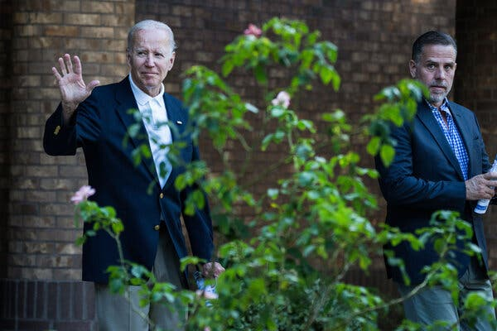

Republicans suggest that President Biden has been complicit in a scheme to profit from his position through Hunter Biden.Credit...Haiyun Jiang/The New York Times

**Hunter’s Associates and Joe Biden**

Hunter Biden has always maintained that he avoided discussing his business activities with his father. But they sometimes came up, such as when the elder Mr. Biden found out about his son’s board seat at Burisma and [called to say](https://www.newyorker.com/magazine/2019/07/08/will-hunter-biden-jeopardize-his-fathers-campaign), “I hope you know what you are doing.”

Republicans have pointed to a series of encounters between the elder Mr. Biden and his son’s business associates to build a case that they were working with each other. The Bidens and many of their associates tell a different story, saying that the encounters were typically fleeting and involved no substantive discussions even if they provided Hunter’s associates with a degree of access to his father.

One such encounter took place in 2015, shortly before Beau’s death. Vice President Biden, increasingly concerned about Hunter, jumped at opportunities to spend time with him, and he stopped by a dinner for the World Food Program USA charity that was arranged by Hunter and attended by some of his and Mr. Archer’s associates and friends.

Afterward, Mr. Pozharskyi of Burisma wrote an email to Hunter in broken English thanking him for “giving an opportunity to meet your father and spent some time together.”

The Times spoke to five of the roughly 14 guests at the dinner. None of them remembered Vice President Biden engaging substantively with Mr. Pozharskyi, who did not respond to repeated requests for comment.

“I remember the vice president coming in, and he did not go around the table. He just simply waved at everybody,” recalled one attendee, Father Alex Karloutsos of the Greek Orthodox Archdiocese of America. “I did not hear any business exchanges with anybody.”

ADVERTISEMENT

[Continue reading the main story](https://www.nytimes.com/2023/01/11/us/politics/hunter-biden-investigations.html?te=1&nl=from-the-times&emc=edit_ufn_20230113#after-story-ad-32)

Vice President Biden had a similar encounter during a trip to Beijing in 2013.

Hunter Biden, who had accompanied his father, arranged to meet with two of his associates from the BHR deal in the coffee shop of the hotel where his father’s delegation was staying. They were standing along with other Chinese well-wishers at a rope line to greet the vice president as he walked inside. Hunter Biden saw them there and briefly introduced them to his father.

As vice president, Mr. Biden met regularly with Eric Schwerin, his son’s business manager, including trips to the White House — a pattern that Republicans claim shows an intersection of Hunter’s business with his father.

But according to family members and former White House officials, Mr. Schwerin did not discuss Hunter’s business activities with the vice president. Having grown close to the Biden family through his long relationship with Hunter, he volunteered to keep track of the elder Mr. Biden’s personal finances and visited him at the White House to make sure he signed important papers, and paid his household bills and taxes on time. (Ethics rules prohibited using White House staff members for those tasks.)

On occasion, Mr. Schwerin would pay a bill for Vice President Biden out of one of his son’s accounts and then assure that he was repaid. House Republicans [have seized on a 2010 email](https://republicans-oversight.house.gov/wp-content/uploads/2022/11/Interim-Staff-Report-A-President-Compromised-The-Biden-Family-Investigation-1.pdf) documenting one such transaction to assert that the Bidens shared bank accounts and possibly profits from the younger Mr. Biden’s work abroad.

Image

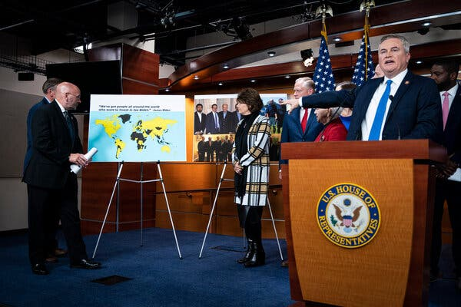

Representative James R. Comer of Kentucky, the chairman of the House Oversight Committee, speaking about the Republicans’ investigation into Hunter Biden in November.Credit...Al Drago for The New York Times



But according to Biden family members and business associates, Hunter and his father never had joint bank accounts or direct access to each others’ money. And at the time of the email, Hunter had yet to embark on his foreign deals.

Like Mr. Schwerin before him, Mr. Archer was welcomed into the Biden family, creating another set of links that Republicans have used to try to connect President Biden to his son’s activities.

ADVERTISEMENT

[Continue reading the main story](https://www.nytimes.com/2023/01/11/us/politics/hunter-biden-investigations.html?te=1&nl=from-the-times&emc=edit_ufn_20230113#after-story-ad-33)

“Happy you guys are together,” Vice President Biden wrote to Mr. Archer about Hunter in 2011 on White House letterhead after Mr. Archer attended a luncheon at the State Department for Hu Jintao, then president of China.

Republicans also point to a picture of Mr. Archer and Vice President Biden on a golf course, and to a 2014 visit Mr. Archer made to the White House shortly before Hunter’s appointment to the Burisma board. During the visit, according to emails and interviews, Mr. Archer did not talk to Hunter’s father about the Ukrainian company, as Republicans have suggested. Mr. Archer was there with his young son, who was working on a papier-mâché model of the White House for his class.

To try to make the case that the elder Mr. Biden played a role in his son’s dealings with Mr. Ye, Republicans point to [statements by Tony Bobulinski](https://www.nytimes.com/2020/10/25/us/politics/bidens-china.html), an associate who has claimed that Hunter’s father had at least some knowledge of the possible venture with CEFC. They also cite messages in which another participant in the negotiations, James Gilliar, floated the possibility that a 10 percent stake in their prospective company could be set aside for the “big guy.”

Mr. Gilliar [later said](https://www.wsj.com/articles/hunter-bidens-ex-business-partner-alleges-father-knew-about-venture-11603421247) he was unaware of any involvement in the CEFC discussions by Hunter’s father at any time. Family members and other participants say the elder Mr. Biden never met with Mr. Ye or other company executives.

In a November news conference where he discussed the CEFC negotiations, Representative James R. Comer, a Kentucky Republican and the chairman of the House Oversight Committee, said there was evidence President Biden was “a ‘partner’ with access to an office.”

He displayed a poster-size copy of an email Hunter Biden sent in 2017 to the manager of the building where he had an office in Washington asking for keys to be made for his “new office mates,” a group that, Hunter wrote, included his father, his mother and one of Mr. Ye’s representatives in the United States. In addition to the keys, he requested a new signboard for the door of his office listing CEFC, Hudson West and the Biden Foundation, which his parents started after leaving the White House.

The younger Mr. Biden has told friends that he wrote the email to the building manager seeking to impress her as a serious business executive because he was afraid he would lose his lease after security cameras spotted him sneaking a homeless person into the building so they could smoke crack together.

ADVERTISEMENT

[Continue reading the main story](https://www.nytimes.com/2023/01/11/us/politics/hunter-biden-investigations.html?te=1&nl=from-the-times&emc=edit_ufn_20230113#after-story-ad-34)

He never followed up on his email, and according to a spokeswoman for the building, the keys that he ordered were never picked up, the suite’s signboard was never changed, and the building had no discussions with either his father’s foundation or CEFC about moving in.

In February 2018, Hunter terminated his lease in the building.

Image

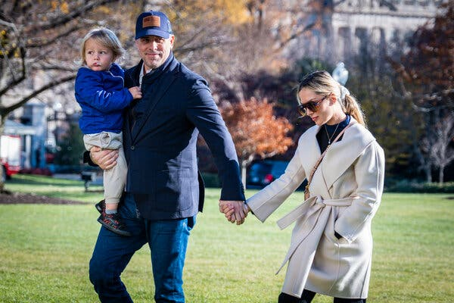

After Hunter Biden married Melissa Cohen, he rededicated himself to staying sober.Credit...Pete Marovich for The New York Times



**A $2 Million Tax Bill**

That same month, the Senate confirmed Mr. Weiss’s nomination by Mr. Trump as the U.S. attorney in Delaware. He was ultimately given responsibility for overseeing the various investigations touching on Hunter Biden.

After his father entered the presidential race in 2019, and with his relationship with Burisma under [renewed scrutiny and political attack](https://www.nytimes.com/2019/05/01/us/politics/biden-son-ukraine.html), Hunter gave up his seat on the company’s board, cutting off his main source of income.

That May, he married Melissa Cohen, his second wife, and he rededicated himself to staying sober.

A few months later, Hunter and Melissa made plans to honeymoon on Mexico’s Pacific Coast. But when he went to check in for their flight, he was told his passport had expired. He rushed to a passport renewal agency, where he learned firsthand what his accountant had warned him about the previous year: The State Department would not give him a new passport because of the outstanding tax liens.

The couple honeymooned in Hawaii, and Hunter Biden tried in vain to get in touch with his accountant, Mr. Morgan. But Mr. Morgan had passed away. Hunter hired new accountants, who reminded him that he had never filed his 2016 and 2017 returns. (The 2016 returns that had been prepared for him would later turn up in a box he stored in Hallie Biden’s house.)

The accountants estimated that he owed about $2 million in back taxes, plus accumulated interest and penalties. He did not have that much, so he filed the returns without paying the bill, and his accountants reached out to the I.R.S. to discuss a payment plan.

The I.R.S. did not respond and he did not understand why — until December 2020, when, about a month after his father won the presidency, [CNN broke the news of Mr. Weiss’s investigation](https://www.cnn.com/2020/12/09/politics/hunter-biden-tax-investigtation/index.html).

When Mr. Trump heard, he was furious at William P. Barr, his attorney general, for not making Mr. Weiss’s investigation public during the campaign.

By the middle of 2021, it was clear to Hunter’s legal team that Mr. Weiss was considering bringing charges against him for not paying his taxes.

That October, Hunter Biden borrowed $2 million from [a wealthy Los Angeles writer and lawyer](https://www.nytimes.com/2022/05/10/us/politics/hunter-biden-kevin-morris-lawyer.html) named Kevin Morris, with whom he had become friends, and he paid the I.R.S. the full amount that his accountants estimated he owed. His liens were similarly paid.

By making the payments, former officials said, he complicated Mr. Weiss’s ability to charge him with tax evasion because juries often question why the government has indicted someone who has paid his taxes. His lawyers have argued to prosecutors that similar tax cases have been handled without criminal charges.

The possible gun charge could also present hurdles for prosecutors. Lying about drug use on the federal form is rarely prosecuted unless it is added to more serious crimes and when it is used to extract cooperation from a witness. Current and former officials say tens of thousands of Americans, out of the 25 million who buy guns each year, lie on their forms and are not prosecuted.

Hunter Biden’s lawyers have provided the Justice Department with evidence of how the U.S. attorney’s office in Delaware has never brought a stand-alone gun charge for lying about drug use.

Hunter has a growing number of lawyers and advisers. The prominent criminal defense lawyer Chris Clark has been dealing with the Justice Department investigation. Hunter recently hired the high-profile Washington lawyer Abbe Lowell to deal with the congressional investigations.

At the White House one evening last month, Hunter found himself among the first of the guests to arrive for a state dinner in honor of President Emmanuel Macron of France. Among the few other guests there at the moment was Kevin McCarthy, then the House Republican leader and now the speaker, who has eagerly promoted hearings into Hunter and his father.

Hunter and Melissa walked over to where Mr. McCarthy was standing with his mother, his guest for the evening. The two men shook hands.

“Mrs. McCarthy, you look beautiful,” Hunter said, according to a person who was present. He continued with a smile, “I’m a friend of your son’s.”

Adam Goldman and Glenn Thrush contributed reporting. Julie Tate and Kitty Bennett contributed research.

Michael S. Schmidt is a Washington correspondent covering national security and federal investigations. He was part of two teams that won Pulitzer Prizes in 2018 — one for reporting on workplace sexual harassment and the other for coverage of President Trump and his campaign’s ties to Russia. [@NYTMike](https://twitter.com/NYTMike)

Katie Benner covers the Justice Department. She was part of a team that won a Pulitzer Prize in 2018 for public service for reporting on workplace sexual harassment issues. [@ktbenner](https://twitter.com/ktbenner)