**In Biden Documents Story, Stenography and Scandal Take Center Stage**

by [JULIE HOLLAR](https://fair.org/author/julie/)

* FAIR
* JANUARY 12, 2023

News coverage of the revelation that President Joe Biden found and returned classified documents left over from his time as vice president **offers a textbook example of corporate media’s twin commitments to scandal and stenography**.

After **CBS Evening News** announced the “breaking news” on its [January 9](https://www.cbsnews.com/news/biden-center-classified-documents/?ftag=CNM-00-10aab7e&linkId=196611442) program, teeing up the right-wing media machine by directly framing the story in comparison to Donald Trump’s Mar-a-Lago document scandal, many corporate outlets covered the story by focusing on what each party had to say about it—rather than what the general public ought to understand about it.

**‘Breaking news’**

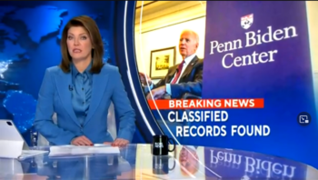

***CBS****‘s Norah O’Donnell (****CBS Evening News****,*[*1/9/23*](https://www.cbsnews.com/news/biden-center-classified-documents/)*) reports the “breaking news” that Biden returned classified documents that he found to the National Archives.*

“Breaking News: Classified Records Found,” announced the screen behind **CBS** anchor Norah O’Donnell, who introduced the segment with an ominous tone. After explaining the known facts, reporter Adriana Diaz noted that “this development comes as the Justice Department is investigating former president Trump’s handling of classified documents.”

Diaz pointed out that Biden had been “critical of Trump” in an interview with **60 Minutes**‘ [Scott Pelley](https://fair.org/home/another-60-minutes-puff-piece/) (9/18/22). The **Evening News** report aired a clip of that interview, in which Pelley asked Biden what he thought about when he learned about the top-secret documents found at Trump’s private residence in Florida. Biden responded: “How that could possibly happen. How anyone could be that irresponsible.”

**CBS** followed up that clip with a former federal prosecutor saying that the Biden case was “completely different from the Mar-a-Lago case,” because it was self-reported, suggesting “a lack of intentional conduct,” in contrast to Trump [apparently](https://www.justsecurity.org/83034/tracker-evidence-of-trumps-knowledge-and-involvement-in-retaining-mar-a-lago-documents/) intentionally taking the classified documents.

It’s the kind of independent assessment that, at an outlet more concerned with news value than clickbait, would inform the setup of the story. The **CBS** report also freely noted that the Biden documents were “small in number” (**CBS**‘s web story put the number at “[roughly 10](https://www.cbsnews.com/news/biden-center-classified-documents/?ftag=CNM-00-10aab7e&linkId=196611442)”) while the Trump documents numbered “over 300.” The piece also noted that while “the National Archive retrieved the [Biden] documents the day after they were discovered” and Biden named a Trump-appointed Justice Department lawyer to conduct an initial investigation, Trump “failed to comply with multiple requests to return” the documents at Mar-a-Lago “for over a year.”

But at **CBS**, the question, *Is this story something people should be concerned about?* comes after the question, *Can we set this up to look like a political scandal?* And so the story concluded darkly, “the attorney general will decide if a criminal investigation is warranted.”

**Scrupulously stenographic**

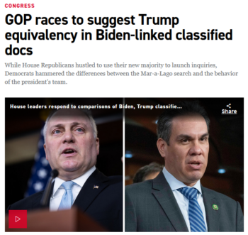

***Politico****(*[*1/10/23*](https://www.politico.com/news/2023/01/10/house-gop-trump-biden-classified-docs-00077252)*) suggests your take on the story should depend on which party you tend to believe.*

The report certainly got **CBS** lots of play—if not lots of love—among right-wing media, with the **60 Minutes** interview taking center stage in several conservative commentaries (e.g., **FoxNews.com**, [1/10/23](https://www.foxnews.com/media/liberal-media-roasted-excusing-biden-document-scandal-when-will-fbi-raid-his-home); **USA Today**, [1/10/23](https://www.usatoday.com/story/opinion/columnist/2023/01/10/biden-classified-documents-double-standard-trump/11022762002/)). But some centrist corporate outlets reporting on **CBS**‘s scoop did little better in informing the public, instead adhering scrupulously to the reporting-as-stenography axiom of political reporting.

This (unspoken) axiom states that political stories must be covered by simply reporting what representatives of the Republican and Democratic parties say, with little to no analysis of the truth or the relevance of those statements. In this way, media outlets attempt to shield themselves from accusations of bias from the powerful. Note that this form of reporting requires no seeking out of alternative perspectives that might disagree with *both* parties.

Here’s how **Politico** ([1/10/23](https://www.politico.com/news/2023/01/10/house-gop-trump-biden-classified-docs-00077252)) headlined it: “GOP Races to Suggest Trump Equivalency in Biden-Linked Classified Docs.”

The piece launched in with the he said/she said:

House Republicans are racing to draw a straight line from newly discovered classified documents found by President Joe Biden’s personal attorneys to the legal jeopardy enveloping former President Donald Trump over his own storage of top-secret material at Mar-a-Lago.

And Democrats aren’t having it.

It wasn’t until the 16th paragraph (of the 26-paragraph piece) that the reporters offered any sort of assessment of either side’s claims. Prior to that, it’s all partisan talking points. Not a single independent expert is quoted in the entire piece.

This kind of coverage is worse than useless. Without offering more than the slightest hint of evaluation, stenographic reporting of partisan battles will always benefit the party willing to make the most outlandish claims, because there is virtually no downside.

**‘Would have been explosive’**

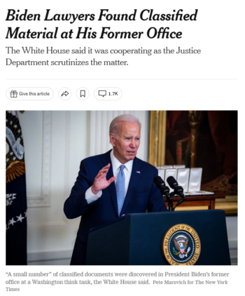

*The****New York Times****(*[*1/9/23*](https://www.nytimes.com/2023/01/09/us/politics/biden-classified-documents.html)*) treats “matters of political reality” as though they have nothing to do with, you know, reality.*

In its main initial report ([1/9/23](https://www.nytimes.com/2023/01/09/us/politics/biden-classified-documents.html)), an entire team of four **New York Times** reporters tasked to the story wrote:

The White House statement said that it “is cooperating” with the department but did not explain why Mr. Biden’s team waited more than two months to announce the discovery of the documents, which came a week before the midterm congressional elections when the news would have been an explosive last-minute development.

Of course, the news would only be “explosive” because the right wing would pretend it is, and the centrist media like the **Times** would predictably follow suit so as not to appear biased—while in the next breath acknowledging that the Biden document circumstances “appeared to be significantly different” from the Trump document circumstances. But who cares:

Still, whatever the legal questions, as a matter of political reality, the discovery will make the perception of the Justice Department potentially charging Mr. Trump over his handling of the documents more challenging. As a special counsel, Mr. Smith is handling that investigation, along with one into Mr. Trump’s efforts to overturn the 2020 election results and the January 6 attack on Congress, under Mr. Garland’s supervision.

Moreover, the discovery will fuel the fires on Capitol Hill, where Republicans who have just taken the House majority were already planning multiple investigations of the Biden administration, including the decision to have the FBI search Mar-a-Lago.

**‘Fresh narrative’**

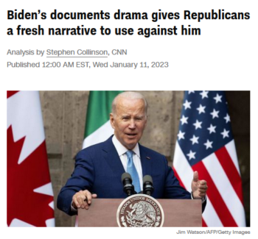

*“Politically, this drama will run and run,”****CNN****(*[*1/11/23*](https://www.cnn.com/2023/01/11/politics/biden-documents-republicans)*) promises–while ignoring the cable news giant’s own role in determining which stories have legs.*

**CNN** ([1/11/23](https://www.cnn.com/2023/01/11/politics/biden-documents-republicans)) adopted a similar attitude. On its highly trafficked homepage, it boosted the headline: “Biden’s Documents Drama Gives Republicans a Fresh Narrative to Use Against Him.” The analysis piece by [Stephen Collinson](https://fair.org/home/medias-election-lesson-ambitious-dems-must-move-to-the-right/) repeatedly drew a distinction between the Biden and Trump cases, yet argued that the fact that the GOP’s narrative “may not reflect the truth of the matter” is “immaterial”:

In a media environment where partisan news coverage blurs the truth, many Americans will only hear headlines about one president—Biden—who condemned Trump for keeping secret documents and is now guilty of the same offense.

Collinson concluded by pointing out that journalists have been peppering Biden and his surrogates with questions about the documents since the story broke: “Scalise, Comer and other Republicans will certainly ensure that Biden won’t get to stop answering questions on his own classified documents problem any time soon.”

It’s a sleight-of-hand just like that at the **Times**, erasing the role (and culpability) of centrist media in establishing “matter[s] of political reality.” Those questions aren’t just coming from the partisan media, and Scalise, Comer and other Republicans can’t force nonpartisan news outlets to doggedly pursue non-stories. But they don’t have to—those news outlets willingly do it of their own accord, then pretend they have nothing to do with it.

***FAIR’s work is sustained by our generous contributors, who allow us to remain independent***

[**Julie Hollar**](https://fair.org/author/julie/)

Julie Hollar is FAIR’s senior analyst and managing editor. Julie has a Ph.D. in Political Science from the Graduate Center of the City University of New York.